LDR:

 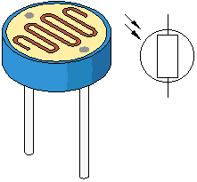

|  |
| --- |
| LDRs or Light Dependent Resistors are very useful especially in light/dark sensor circuits. Normally the resistance of an LDR is very high, sometimes as high as 1000 000 ohms, but when they are illuminated with light resistance drops dramatically. |
|  |

when the torch is turned on, the resistance of the LDR falls, allowing current to pass through it.



Example of light emitting diode:



This is an example of a light sensor circuit :

When the light level is low the resistance of the LDR is high. This prevents current from flowing to the base of the transistors. Consequently the LED does not light.  
  
However, when light shines onto the LDR its resistance falls and current flows into the base of the first transistor and then the second transistor. The LED lights.

The preset resistor can be turned up or down to increase or decrease resistance, in this way it can make the circuit more or less sensitive.

There are two basic circuits using **light dependent resistors** - the first is activated by darkness, the second is activated by light. The two circuits are very similar and just require an **LDR**, some standard [resistors](http://www.reuk.co.uk/Resistor-Colour-Codes.htm), a [variable resistor](http://www.reuk.co.uk/buy-VARIABLE-RESISTORS.htm) (aka potentiometer), and any small signal [transistor](http://www.reuk.co.uk/What-is-a-Transistor.htm)

**REED SWITCH/MAGNETIC SENSOR:**

**What is a reed switch ?**

The basic reed switch consists of two identical flattened ferromagnetic reeds, sealed in a dry inert-gas atmosphere within a glass capsule, thereby protecting the contact from contamination. The reeds are sealed in the capsule in cantilever form so that their free ends overlap and are separated by a small air gap.

**What is a reed sensor ?**

A reed sensor is a device built using a reed switch with additional functionality like ability to withstand higher shock, easier mounting, additional intelligent circuitry, etc.

**What are the advantages in using reed switches ?**

They are hermetically sealed in glass environment, free from contamination, and are safe to use in harsh industrial and explosive environments.

**Photo transistors:**

A phototransistor is an ordinary transistor that has been modified in two ways:

(1) there is a transparent window so that light can shine on the junctions

(2) the structure has been modified to maximize the light capture area. Some phototransistors have an external base lead; others do not.

**Piezo electric sensor:**

A **piezoelectric sensor** is a device that uses the [piezoelectric effect](http://en.wikipedia.org/wiki/Piezoelectric_effect) to measure [pressure](http://en.wikipedia.org/wiki/Pressure), [acceleration](http://en.wikipedia.org/wiki/Acceleration), [strain](http://en.wikipedia.org/wiki/Strain_(materials_science)) or [force](http://en.wikipedia.org/wiki/Force) by converting them to an [electrical](http://en.wikipedia.org/wiki/Electricity" \o "Electricity)charge.

Piezoelectric sensors have proven to be versatile tools for the measurement of various processes. They are used for [quality assurance](http://en.wikipedia.org/wiki/Quality_assurance), [process control](http://en.wikipedia.org/wiki/Process_control) and for research and development in many different industries.

**TILT SENSOR**

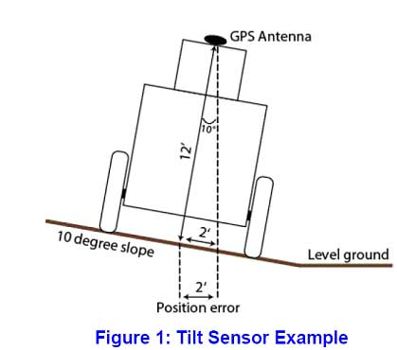

Tilt sensors are used for:

* indicating pitch and roll of vehicles, sail boats, and aircraft.
* Monitoring boom angle of cranes and material handlers.
* Measuring the "look angle" of a satellite antenna towards a satellite.
* Measuring the slope angle of a tape or chain during distance measurement.
* Estimating the height of a building, tree, or other feature using a vertical angle and a distance (determined by taping or pacing).
* Measuring the angle of drilling in well-logging applications.
* Measuring the height of trees or other poles
* Measuring steepness of a ski slope. (<10 deg for beginners, 10-20 "green", 15-25 "blue", 25-35 "black", 35-45 "double black")
* Used as a warning system on the external surface of dewars(to transport cryogenic liquids) to indicate tilt being too much.

**Temperature sensor:**

An analog temperature sensor is pretty easy to explain, it’s a chip that tells you what the ambient temperature is!

These sensors use a solid-state technique to determine the temperature. That is to say, they don’t use mercury (like old thermometers), [bimetalic strips](http://en.wikipedia.org/wiki/Bimetallic_strip" \o "http://en.wikipedia.org/wiki/Bimetallic_strip) (like in some home thermometers or stoves), nor do they use [thermistors](http://en.wikipedia.org/wiki/Thermistor" \o "http://en.wikipedia.org/wiki/Thermistor)(temperature sensitive resistors). Instead, they use the fact as temperature increases, the votage across a diode increases at a known rate. (Technically, this is actually the voltage drop between the base and emitter - the Vbe - of a transistor. By precisely amplifying the voltage change, it is easy to genereate an analog signal that is directly proportional to temperature. There have been some improvements on the technique but, essentially that is how temperature is measured.

Because these sensors have no moving parts, they

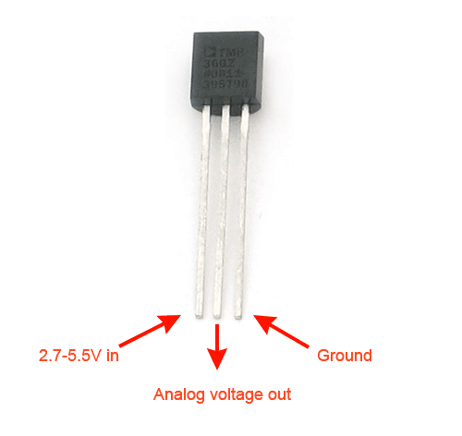

LM35/TMP35 (celsius output) and LM34/TMP34 (farenheit output). The reason we went with the '36 instead of the '35 or '34 is that this sensor has a very wide range and doensn't require a negative voltage to read sub-zero temperatures. Otherwise, the functionality is basically the same

-40°C to 150°C / -40°F to 302°F

SLOT SENSORS:

The main feature of our fork sensors is their reliability with utmost accuracy.  
Even very small objects are reliably detected. High switching frequencies enable the detection of moving objects. All versions have a plug connection and use visible red light.

Features of LPG Sensors:

**Features:**

* Manufacturer Model MQ-5
* High sensitivity to Propane gas
* Stable and long life
* Simple drive circuit

**IR SENSORS:**

it provides a detection range of 35 cm

This sensor can be used for most indoor applications where no important ambient light is present.

However, this sensor can be used to measure the speed of object moving at a very high speed, like in industry

It is the same principle in ALL Infra-Red proximity sensors. The basic idea is to send infra red light through IR-LEDs, which is then reflected by any object in front of the sensor

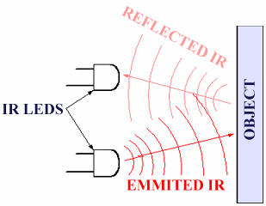

Then all you have to do is to pick-up the reflected IR light. **For detecting the reflected IR light, we are going to use a very original technique: we are going to use another IR-LED**, to detect the IR light that was emitted from another led of the exact same type!

Micro Processor: A micro processor is a digital device that takes an input and process it as per the user given instructions and provides the output.

Micro processor is just like a cpu that is connect with external peripherals to form a complete functional unit.

* ALU
* Registers

General purpose

Spl

Invisible

* BUSES

Embedded systems